Ethics & Compliance Statement

A code of ethics is essential to the conduct of Timberline Helicopters’ business and the honor of the aviation community. To that end, the following is a declaration of the company's ethical expectation of employees.

Integrity is a Core Value at Timberline Helicopters

We believe in being honest and showing a consistent and uncompromising adherence to strong moral and ethical principles and values.

We will maintain the highest standards of integrity at all times.

Supporting those high standards, part of our strategy will be to find the most efficient means possible to ensure full regulatory compliance and product quality while pursuing growth and the financial health of the Company.

We shall conduct our professional lives in accordance with the Employee’s Handbook’s Ethics and Quality Policy.

Yours Sincerely,

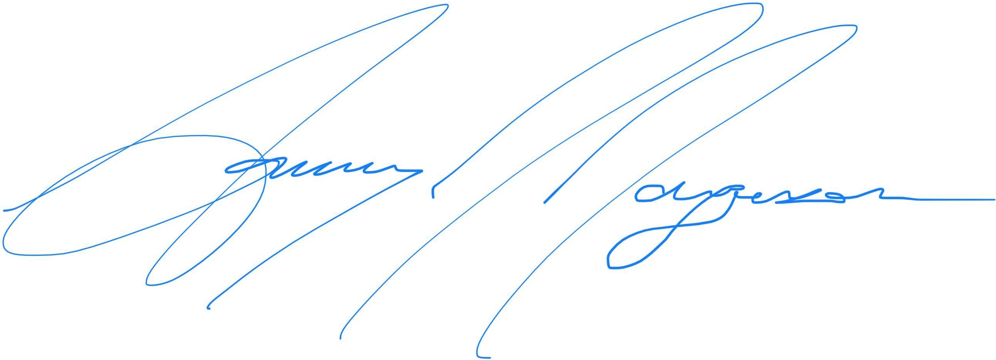

Ammy Jorgenson
President & CEO

