Social and Environmental Responsibility Statement & Policy

“Corporate social responsibility is the continuing commitment by business to behave ethically and contribute to economic development while improving the quality of life of the workforce and their families as well as of the local community and society at large.”

-Statement from the World Business Council for Sustainable Development.

At Timberline Helicopters Inc. (THI), we believe in our responsibility to promote and engage in achievable sustainability efforts. We have empowered all employees to make a concerted effort to make an impact when possible. As a small business, our biggest resource is our people and awareness.

Our focus is to innovate, reduce, reuse, recycle when possible. When available, we urge all employees to make smart choices when conducting business on behalf of THI. Moreover, we invite all employees to engage in sustainability efforts outside of work.

Please note the following best practices and examples of THI applications and initiatives:

- Invest in clean technologies
- Using energy from renewable sources
- Reduction in the business use of transport
- Reduction in car usage
- Buy alternative, environmentally friendly products
- Waste minimization, re-cycling
- Smaller fleet options and explore hybrid/plug-in options

THI remains committed to sustainable social and environmental activities. Social and environmental responsibility is considered by THI as a normal part of business development and growth. We have a duty to act in best interests of our environment and society as a whole.

We thank all employees and contractors for your support on this matter.

Yours Sincerely,

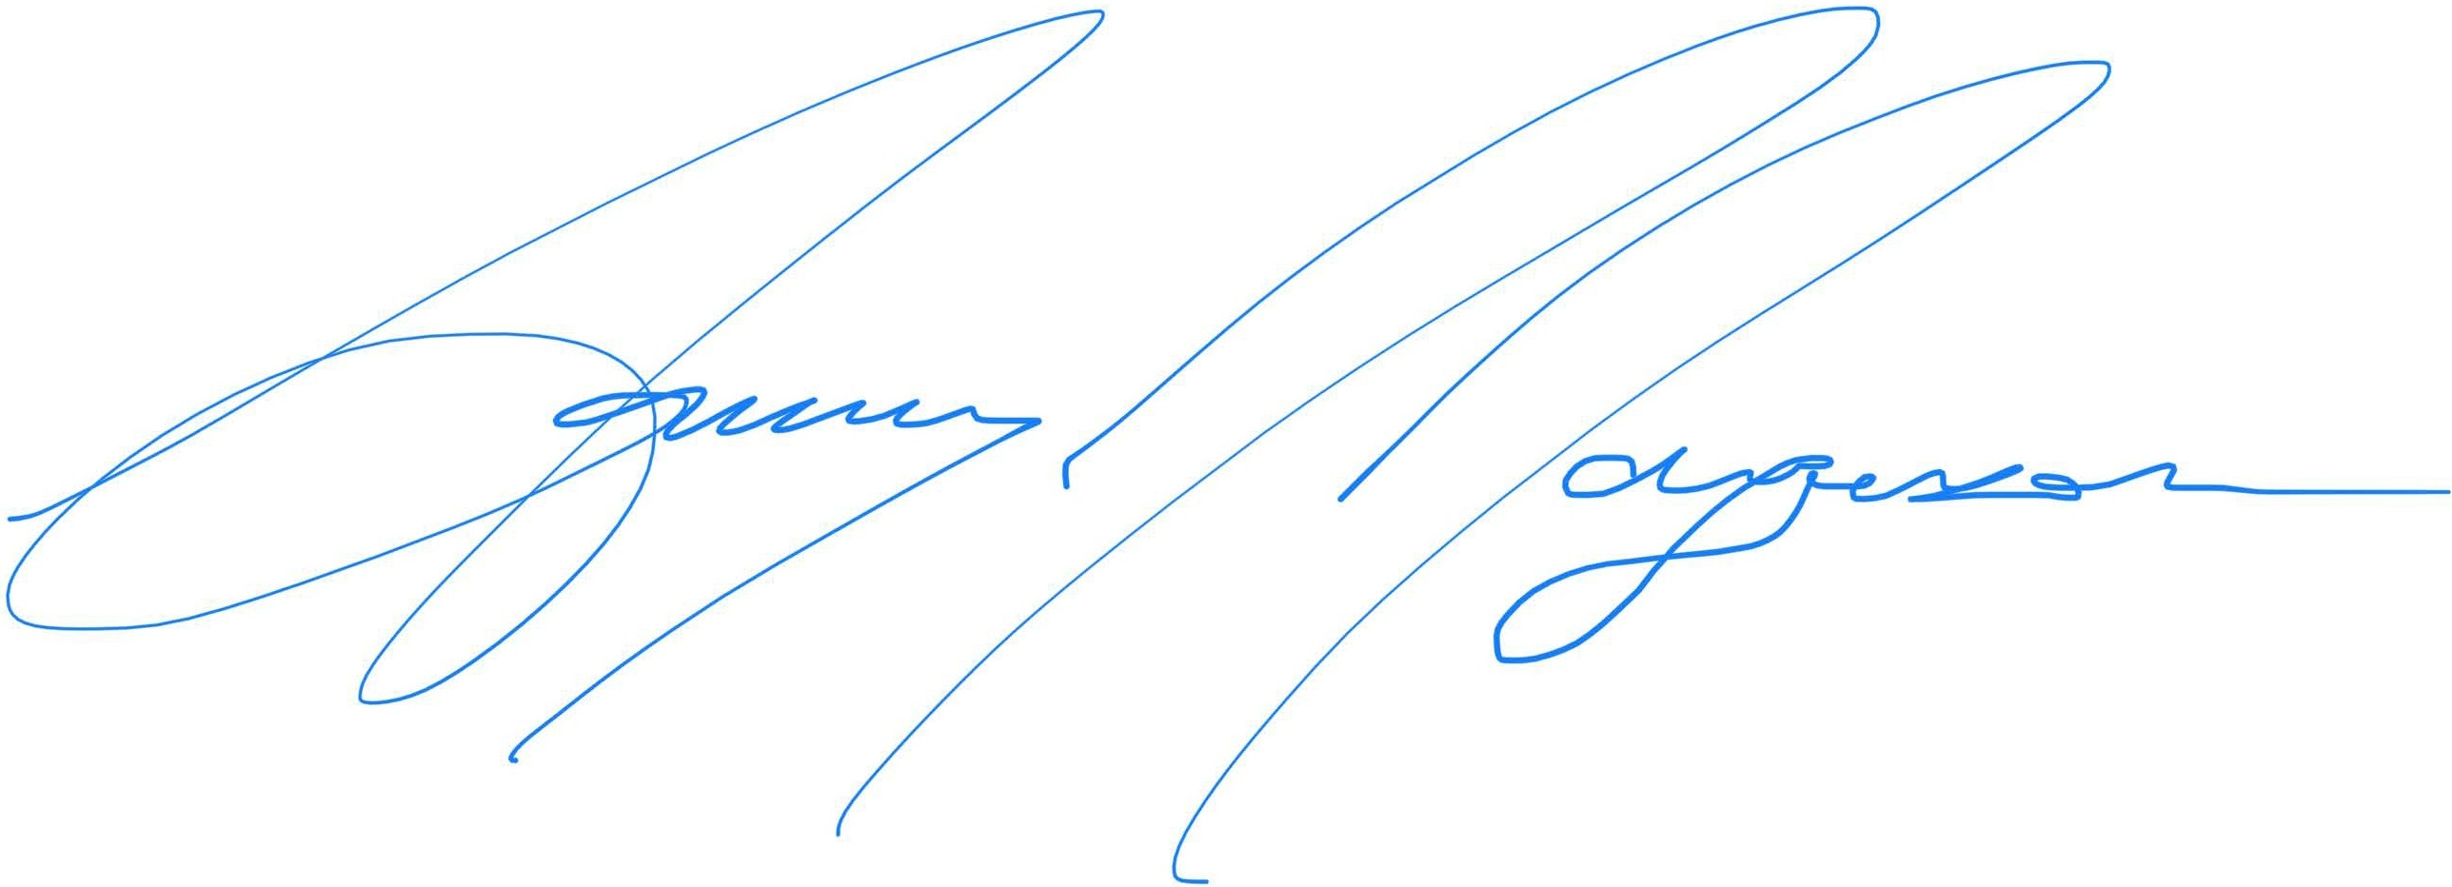

Ammy Jorgenson
President & CEO

Some of our previous and ongoing initiatives include:

Environmental Protection
- Our designed Purge Fuel Collector was an innovative solution that addressed the dumping of purged fuel on engine shut down to the environment in UH-60 helicopters and is now mandatory on all UH-60 helicopters used in Forestry Service applications.

- Our follow-on initiative is to push and have this mandatory across public use, government and military UH-60 aircraft.

- Timberline understands the importance of bees to the eco-system and has invested in establishing multiple bee farms on Timberline property to help with environmental impact.

Invest in Renewable Energy Technologies / Reduce Energy Usage
- Our lean six sigma designed proposed new facility will feature solar panels, LED lighting, and in slab heating to minimize energy consumption and improve efficiencies.

- We are exploring options for the use of alternate-fuels and electric/hybrid technologies across our fleet.

Reduction in Emissions
- We encourage a remote work force culture, carpooling and the use of public transport systems.

Waste minimization, Re-cycling and Community
- We have an ongoing collaboration with the local Air Force Ordinance Division to safely dispose of fire bottle squibs upon expiry.

- We promote recycling and safe disposal programs across our operational functions.

